**ANIMAL SHELTER MANAGEMENT SYSTEM**

1. **Database Planning**

**Planning Process for the Project's Database:**

The planning process for our Animal Shelter Management System Database involves several key stages. The objective of this phase is to understand the project goals, establish project scope, gather data requirements, and identify potential issues early.

* + **Initial Research and Feasibility Study:** This involves understanding the specific needs of an animal shelter, analyzing potential challenges, and determining the feasibility of creating a database to support those needs.
  + **Stakeholder Interviews and Fact-Finding:** Key stakeholders such as shelter staff, veterinarians, and volunteers were interviewed to gather insights on the shelter's operations and their data management needs.
  + **Requirement Prioritization:** Requirements were categorized into mandatory, recommended, and optional, focusing on functionality essential to shelter operations.
  + **Establishing a Development Timeline:** We outlined milestones, deadlines, and deliverables to ensure the project remained on track.

1. **Mission Statement & Objectives**

**Mission Statement**: Our mission is to create an efficient, user-friendly database system to streamline animal shelter operations, improve data accessibility, and ensure reliable information management for animal records, adoption processes, and shelter resources**.**

**Mission Objectives:**

1. **Data Organization:** To store and organize information on animals, adopters, volunteers, and staff.
2. **Efficiency Improvement:** Simplify the adoption process by enabling quick access to animal and adopter profiles.
3. **Accurate Record-Keeping:** Ensure all animal medical history, dietary requirements, and behavior notes are easily accessible.
4. **Resource Management:** Manage shelter resources such as food, medication, and donations effectively.
5. **Data Security:** Safeguard sensitive information on adopters, animals, and shelter operations.
6. **System Definition**

**Scope and Purpose of the System:**

* + **Scope:** The Animal Shelter Management System Database is designed to manage all data related to shelter operations. It includes modules for animal profiles, medical history, adoption records, and volunteer management. Key users of this system include shelter administrators, volunteers, and veterinarians.
  + **Purpose:** This database serves to automate and simplify the animal shelter’s data management processes, minimizing manual record-keeping and enabling data-driven decisions. It aims to provide reliable, real-time information on animal care, adoption processes, and shelter resources, enhancing overall efficiency and transparency.

1. **System Boundary Diagram**

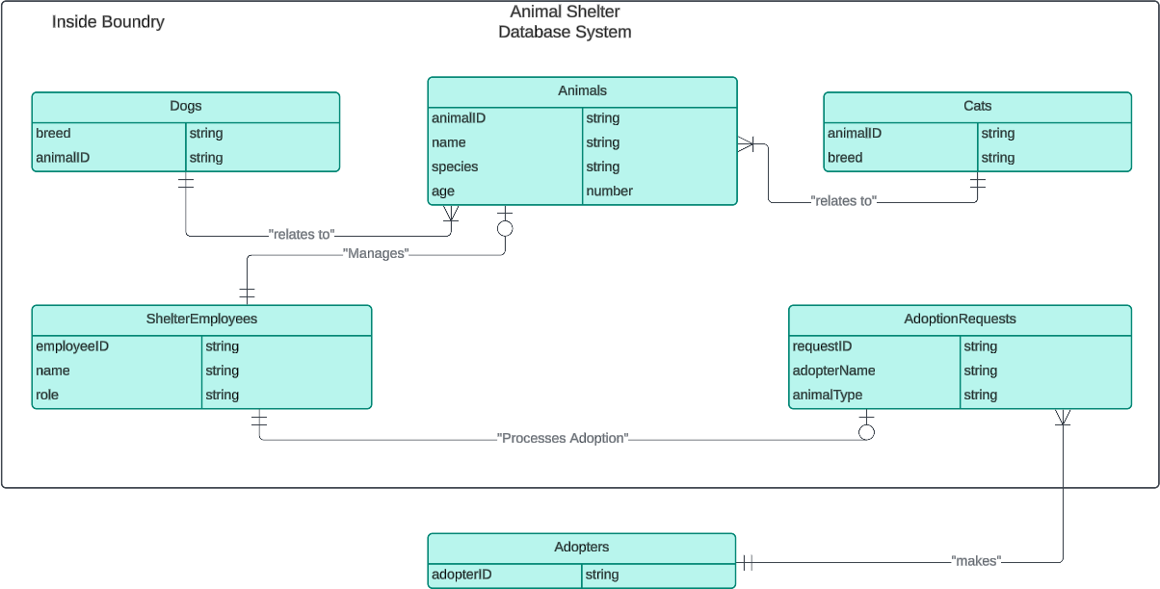

1. **User Views and Data Cross-reference**

|  |  |  |
| --- | --- | --- |
| **User Role** | **User Views** | **Main Data Used** |
| Shelter Administrator | Animal profiles, Adopter  records | Animal details, adopter data,  adoption status |
| Veterinarian | Animal medical history,  behavior notes | Medical records, feeding  requirements, behavior notes |
| Employees | Animal care records,  Employee schedules | Animal details, Employee  schedules, task details |
| Adopter | Adoption applications, animal  details | Animal profiles, adoption  status, adopter data |

1. **Requirement Collection and Analysis**

**Gathering Requirements:**

* **Fact-Finding Techniques:**
  + **Document Analysis:** Reviewed existing shelter records, forms, and reports to understand current data management practices and identify areas for improvement. This analysis provided insights into essential data points and data organization.
  + **Secondary Sources:** Used resources from GitHub and Google Scholar to explore best practices and common challenges related to managing animal shelter data systems. These sources helped inform the functionalities needed to streamline shelter operations.
* **Boundary Diagram Development:** Created a boundary diagram on Lucidchart to visually outline system limits and define interactions with external entities.

**Requirement Analysis**: After gathering input, the data was analyzed to identify critical patterns and prioritize functionalities. For example, several documents highlighted the need for real-time access to medical records. This need guided us to design a module specifically for tracking animal medical history